**DELIVERABLE ONE**

**Moodvie**

# **Introduction**

Users seeking to watch online entertainment are often unable to determine which popular streaming platforms host their movie and compare their respective prices to find the best deal. Any attempts to search these streaming websites by users for movies, are complicated by inaccurate listings, country restrictions and often these sites do not provide a comprehensive overview of the movie’s details.

# 1. Problem statement

1. Popular search engines do not directly check the availability of movies on various streaming platforms accurately, often displaying outdated information. Users feel frustrated and confused as result.
2. Currently the format in which most websites display the reviews, summary, user ratings, price, trailers and streaming site for a given movie is not visually clear and consistent for a user.
3. It is difficult to compare the viewing price of a movie on popular streaming platforms and attempts to do so by search engines, are cluttered.

Ultimately, in light of the above points, we are seeking to simplify the user’s experience of viewing a movie’s details, its streaming availability and cost. We are doing this by creating a web application that integrates multiple APIs from streaming platforms, in order to selectively display information that serves our aforementioned purpose.

# 

# 2.a. Features

# Search for a movie on the main page by its name.

* Generate the information page of a movie
* Display the title and poster of a movie
* Display the cast and director of a movie
* Display a synopsis of the movie
* Show an accurate release date for an upcoming movie or a date of release for an existing movie.
* State the viewing time of a movie
* Display the age restrictions of a movie
* Show the link to the Wikipedia page for the movie
* Show the promotional trailers of a movie
* Provide a link to Youtube so that the user can watch more trailer clips of a movie.
* Display a list of the top three reviews of a movie
* Show the IMDb and Rotten Tomatoes ratings for an existing movie
* Display links to the IMDb and Rotten Tomatoes webpages for a movie if the movie has already been released.
* Display a link to the streaming platforms on which the movie is available to watch
* State and compare the cost of watching a movie on the various platforms.

# 

# 2b. User stories: Tabular

#### **HOME PAGE**

**User Story (1):**

***Feature*** : Search for a movie on the home page by its name

***As a*** user,

***I want to*** search a movie by its name

***So that*** I can see if a certain movie exists.

***Scenario:*** Search for a movie in the main page by its name

***GIVEN*** I am on the homepage

***WHEN*** I click on the search bar and type in a movie

***AND*** click the ‘Search button

***THEN***a list of results of movies which are matching the search terms will show up on the result page with its poster, name and a releasing label.

#### **MOVIE INFORMATION PAGE**

##### **General movie information**

###### **User Story (2):**

***Feature*** : Information page of a movie

***As a*** user,

***I want to*** view the information page of a movie

***So that*** I can know about the movie.

***Scenario:*** View the information page of a movie

***GIVEN*** I am on the information page

***THEN***I can see the poster, title, cast list, director list, movie length,summary, reviews, trailers, available resources, ratings, and relevant links of the movie.

**User Story (3):**

***Feature*** : display the title and poster of a given movie

***As a*** user

***I want to*** see the title and poster of the movie

***So that*** I can decide whether I want to watch it

***GIVEN*** I am on the movie information page

***THEN*** I should see the title and poster of the movie

**User Story (4):**

***Feature*** : display the cast and director of a given movie

***As a*** user

***I want to*** know the cast and director of the movie

***So that*** I have more information when deciding whether I want to watch the movie

***Scenario:*** See the list of cast and director members for a movie

***GIVEN*** I am on the movie information page

***THEN*** I should see all casts and director of the movie at the left side of the movie poster

**User Story (5):**

***Feature*** : a synopsis of the movie

***As a*** user

***I want to*** see a synopsis of the movie

***So that*** I can have a general understanding about the theme of the movie

***GIVEN*** I am on the movie information page

***THEN*** I should see a synopsis of the movie next to the movie poster

**User Story (6):**

***Feature*** : A clearly stated release date of a movie

***As a*** user

***I want to*** see the release date of a given movie

***So that*** I can determine when the movie is released so I can watch it.

***GIVEN*** I am at the information page of a specific movie

***THEN*** I can see the release date of the movie next to the poster of the movie

**User Story (7):**

***Feature*** : A clear representation of a movie’s viewing time.

***As a*** user

***I want to*** see the viewing time of a given movie

***So that*** I can determine how much of my time is required to watch it.

***GIVEN*** I am at the information page of a specific movie

***THEN*** I can see the viewing time of the movie next to the poster of the movie

**User Story (8):**

***Feature*** : A clear representation of the age restriction

***As a*** user

***I want to*** know the age restriction of the movie

***So that***  I can know the audience age restrictions for the movie I searched.

***GIVEN*** I am at the information page of a specific movie

***THEN*** I can see the age restriction of the movie next to its poster

**User Story (9):**

***Feature*** : the link to the Wikipedia page for the given movie

***As a*** user

***I want to*** have the link to the Wikipedia page for a given movie

***So that*** I can view the wikipedia page for the given movie

***GIVEN*** thatI am on the information page of a specific movie

***WHEN*** I click on the wikipedia link next to the movie title

***THEN*** I am redirected to the Wikipedia article page for the given movie

##### **Movie trailer and clips**

**User Story (10):**

***Feature*** : list of trailers links of the movie

***As a*** user

***I want to***  *view the trailer of a movie*

***So that*** I can preview the clips of the movie

***GIVEN*** I am at the information page of a specific movie

***WHEN*** I click on the trailer icon of the movie

***THEN*** I get redirected to the trailer page in Youtube

**User Story (11):**

***Feature*** : the youtube result link for the given movie

***As a*** user

***I want to*** have the youtube result link for the movie I chose

***So that*** I can view more movie clips for the movie on YouTube beside the ones that are already displayed on the information page

***GIVEN*** thatI am on the information page of a specific movie

***WHEN*** I click on the youtube link for more movie clips

***THEN*** I am redirected to the Youtube result for the movie’s promotional videos

##### **Reviews**

**User Story (12)**

***Feature*** : list of the top three reviews of a movie

***As a*** user

***I want to*** read the top three reviews of a given movie

***So that***  I can know what critics and audiences thought about an existing movie

***GIVEN*** I am at the information page of a existing(in theaters or off theater) movie

***THEN*** I can see a review board that consists the top three reviews of the movie

**User Story (13)**

***Feature*** : the IMDB and rotten tomatoes ratings for an existing movie

***As a*** user

***I want to*** know the IMDB and rotten tomatoes ratings for an existing movie

***So that*** I have more information about the quality of the movie.

***GIVEN*** I am on the movie information page

***WHEN*** I look at the bottom of the movie poster

***THEN*** I should see the IMDB and rotten tomatoes ratings for an existing movie

**User Story (14)**

***Feature*** : links to the RottenTomatoes and IMDB pages for the given movie if the movie has already been released.

***As a*** user

***I want to*** have the link to Rotten Tomatoes and IMDB pages for the given movie

***So that*** I can see the feedbacks in greater detail

***GIVEN*** thatI am on the information page of a specific movie

***WHEN*** I click the RottenTomatoes and IMDB links for the given movie

***THEN*** I am redirected to either the RottenTomatoes or IMDB page for the movie

##### **Streaming platform and price comparison**

**User Story (15)**

***Feature*** : the link to the available streaming platforms for the movie

***As a*** user

***I want to*** have the links to the platforms the movie is available on

***So that* I** can choose a platform with reasonable price that allows me to stream the movie legally.

***GIVEN*** thatI am on the information page of a specific movie

***WHEN*** I click any link to a streaming platform

***THEN*** I am redirected to the platform’s homepage to subscribe or login as an existing member

**User Story (16)**

***Feature*** : the price for a certain movie on different platforms

***As a*** user

***I want to*** know the prices to watch a movie on different websites,

***So that*** I know the most financially affordable platform to watch the movie

***GIVEN*** I am on the movie information page

***THEN*** I should see the prices to watch the movie on different streaming platforms at the bottom of the page

### 

# 2.c User Stories - Graphical

|  |
| --- |
| As a user,I want to search a movie by its name so that I can see if a certain movie exists. |

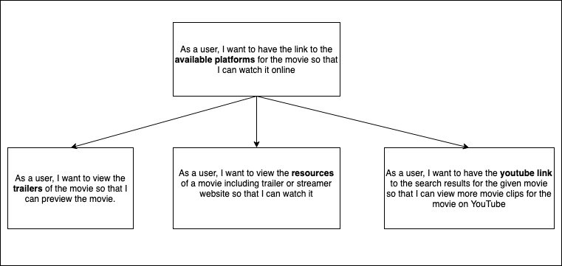

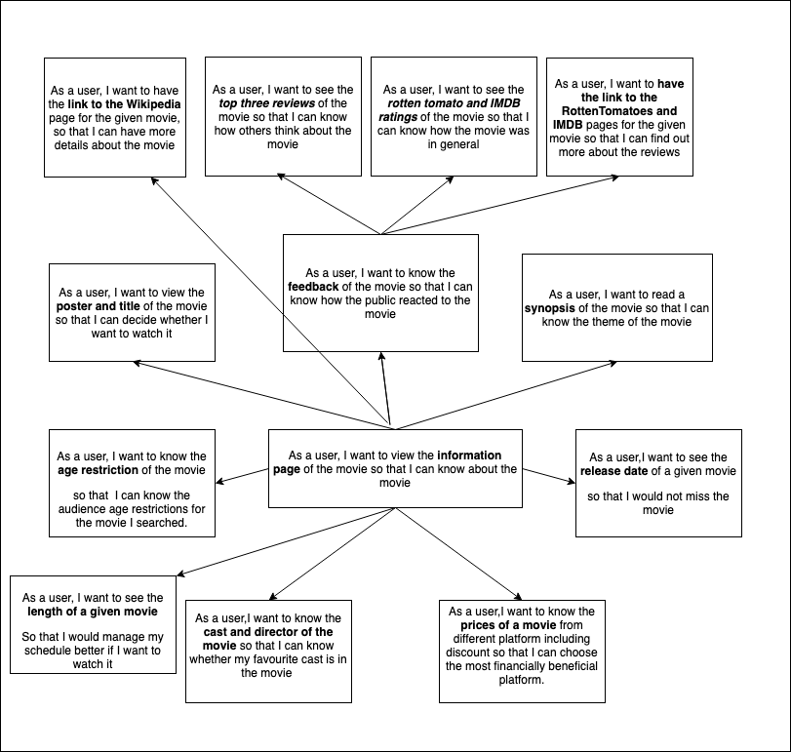

# 3a. Low-fidelity Prototype:

## 3.a. Storyboard Interactions Graphs:

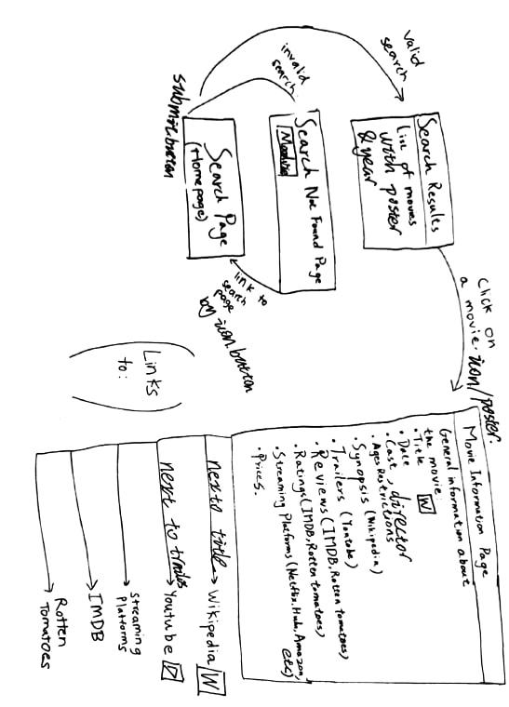

## 3.b. UI Component Sketches:

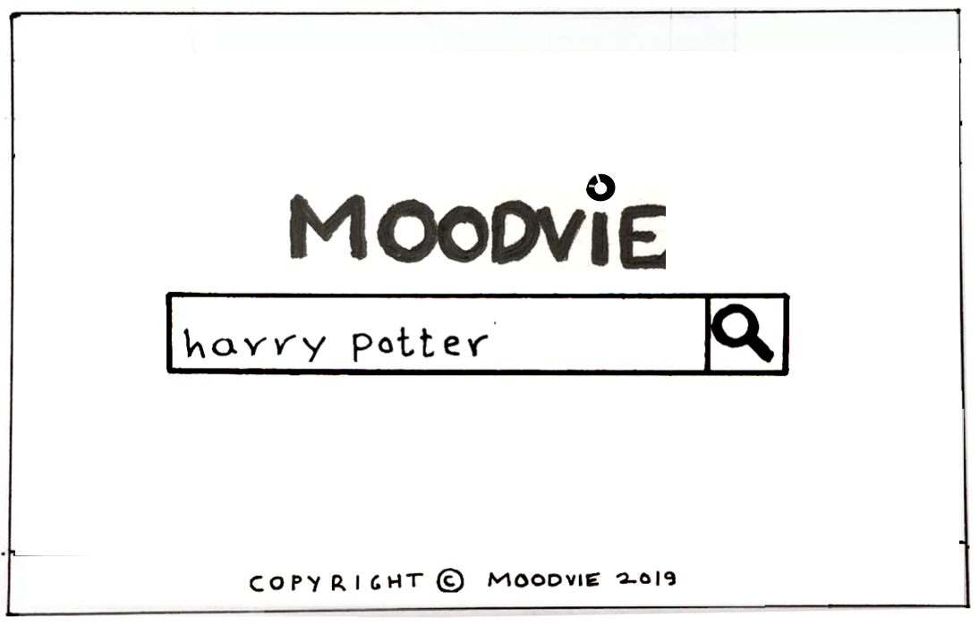

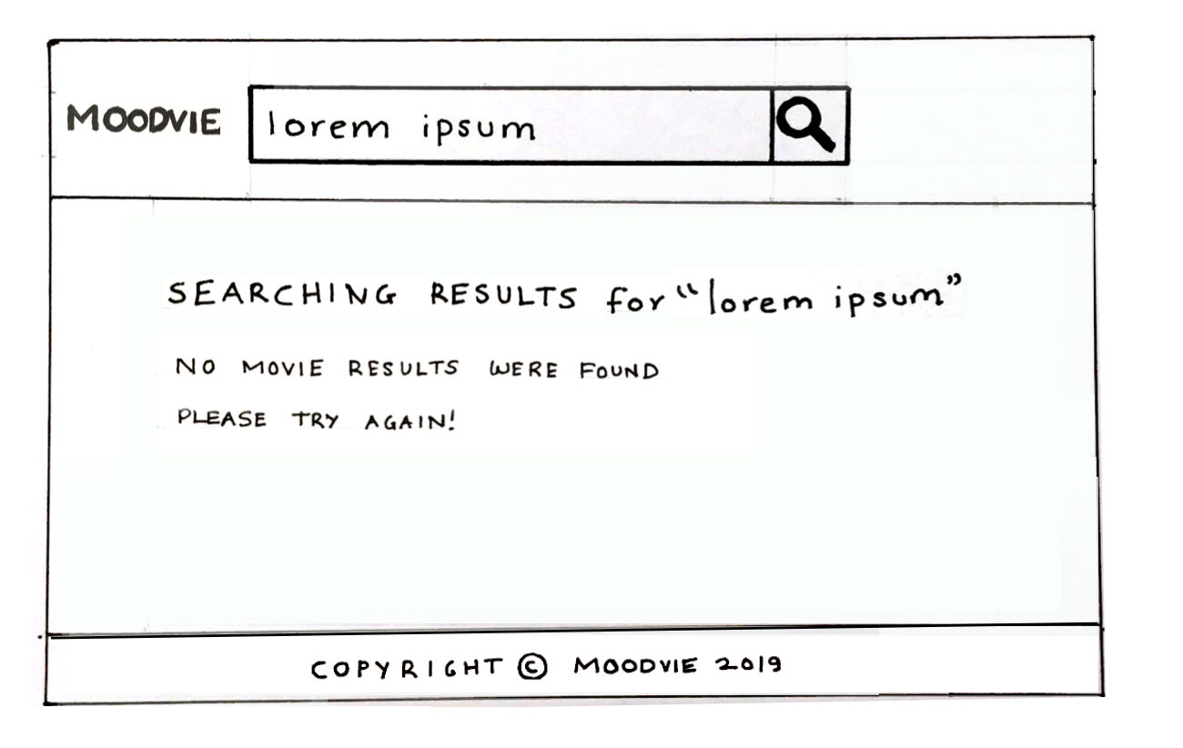

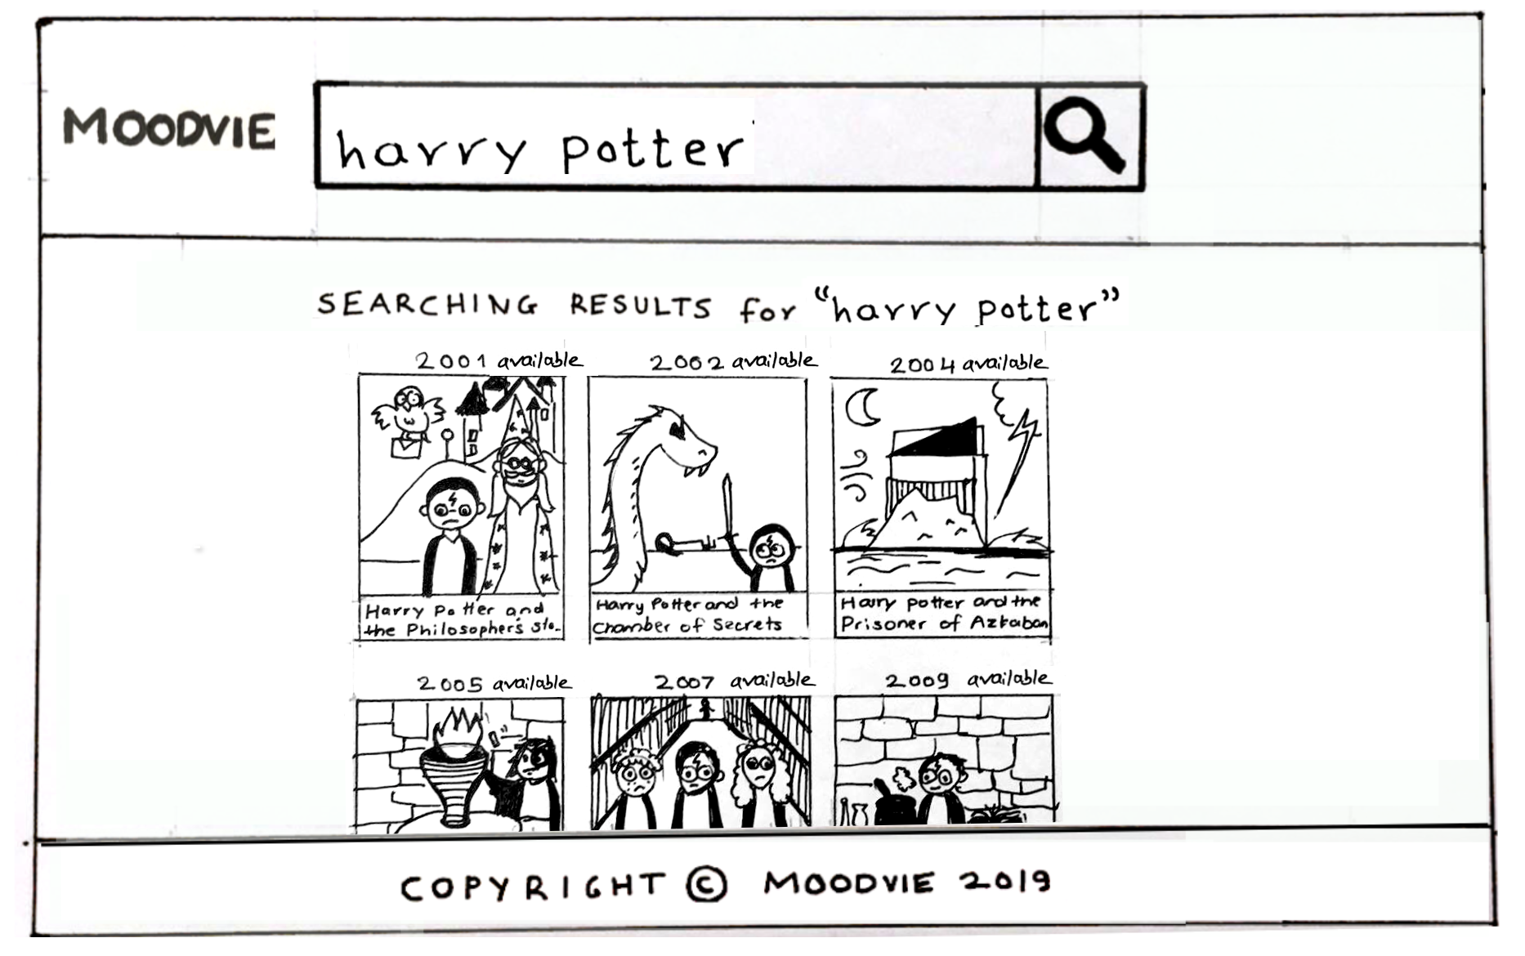

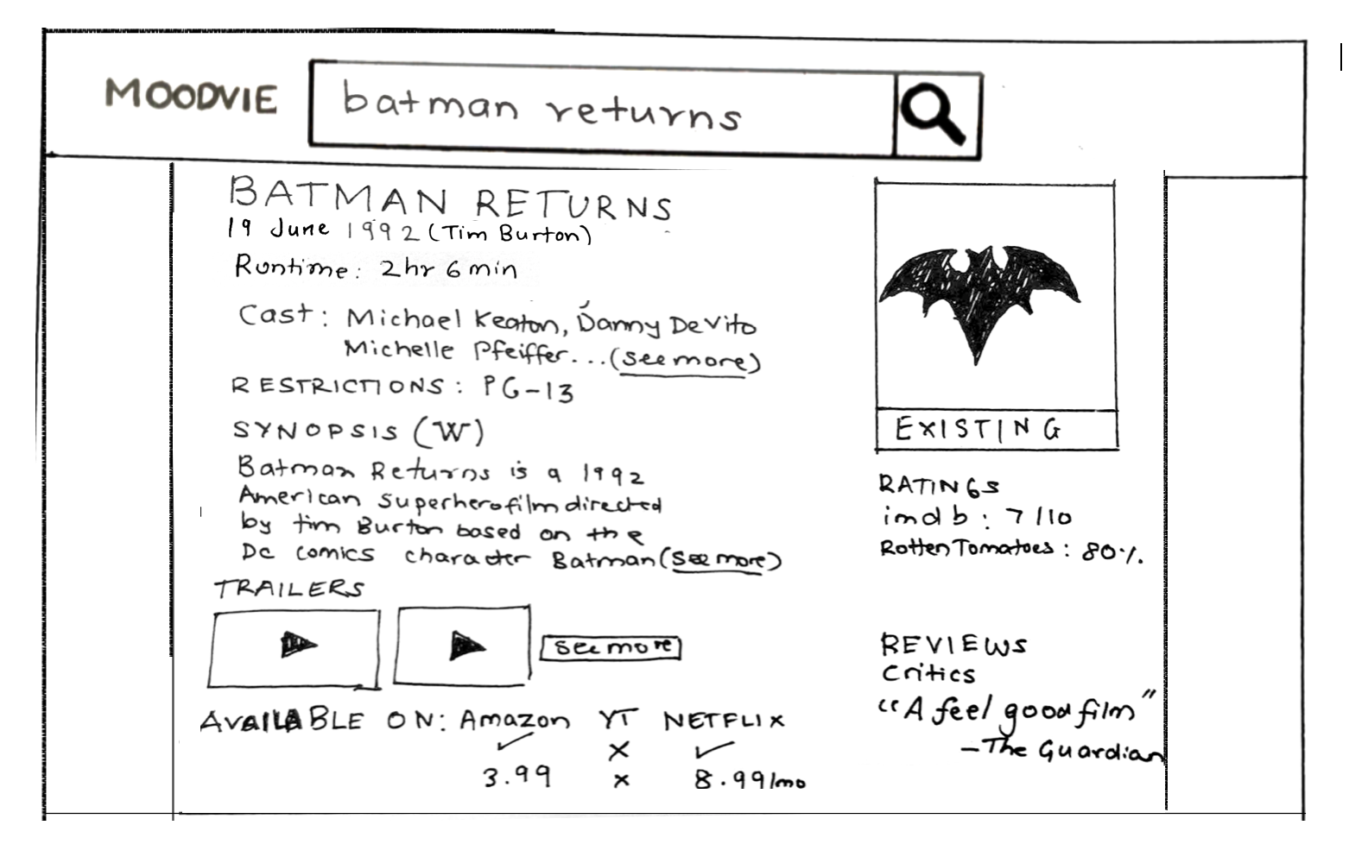

## 

## 

## 

## 

## 

## 

## 

## 

## 

# 3.c. Storyboard Interactions + UI Component Sketches

# 

# 4. High-Fidelity Prototype

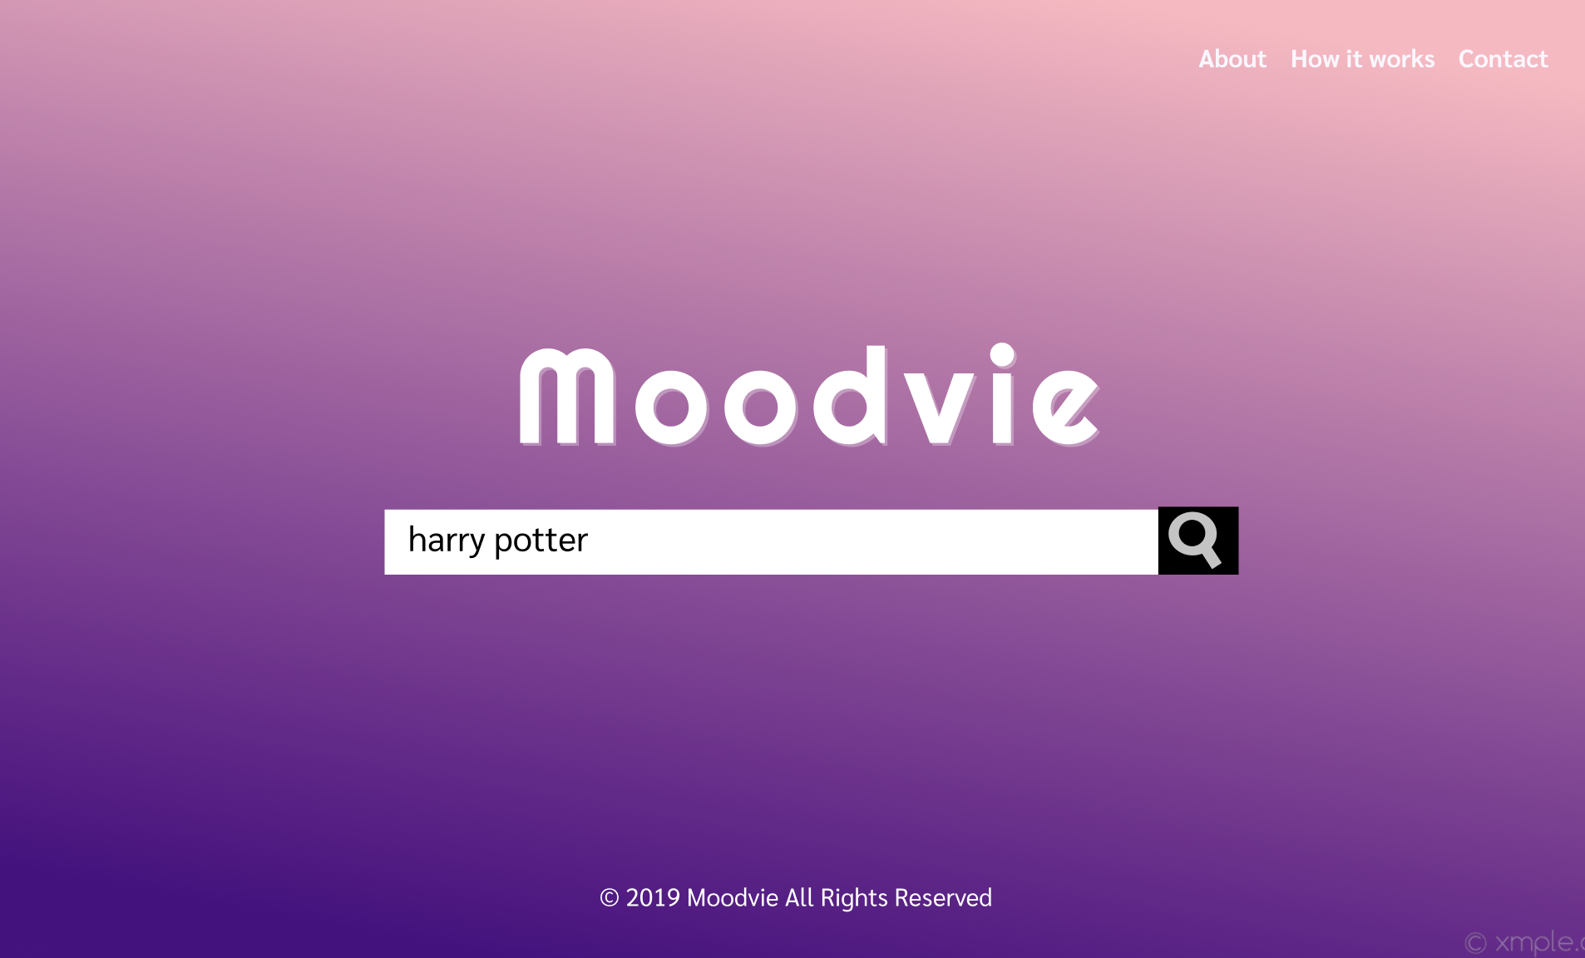

Fig 1. Displays the home page with its main user interface elements (searchbar, search icon).

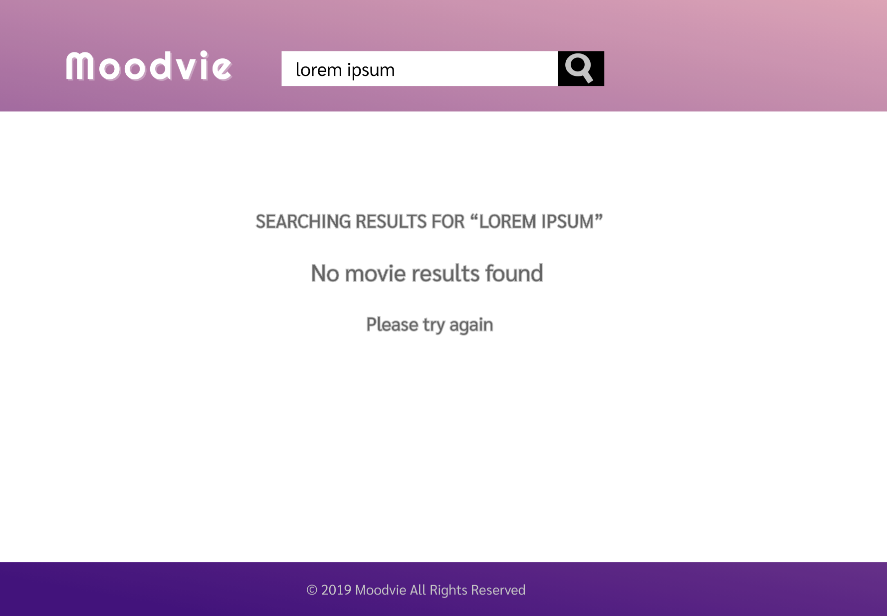

Fig 2. Displays the results page when no movie specified by the user is found.

# 

Fig 3. Displays the results page with movies matching the search, arranged as an matrix for clarity.

Fig 4. Displays the page for an upcoming movie that was searched for by the user and the associated information from APIs. 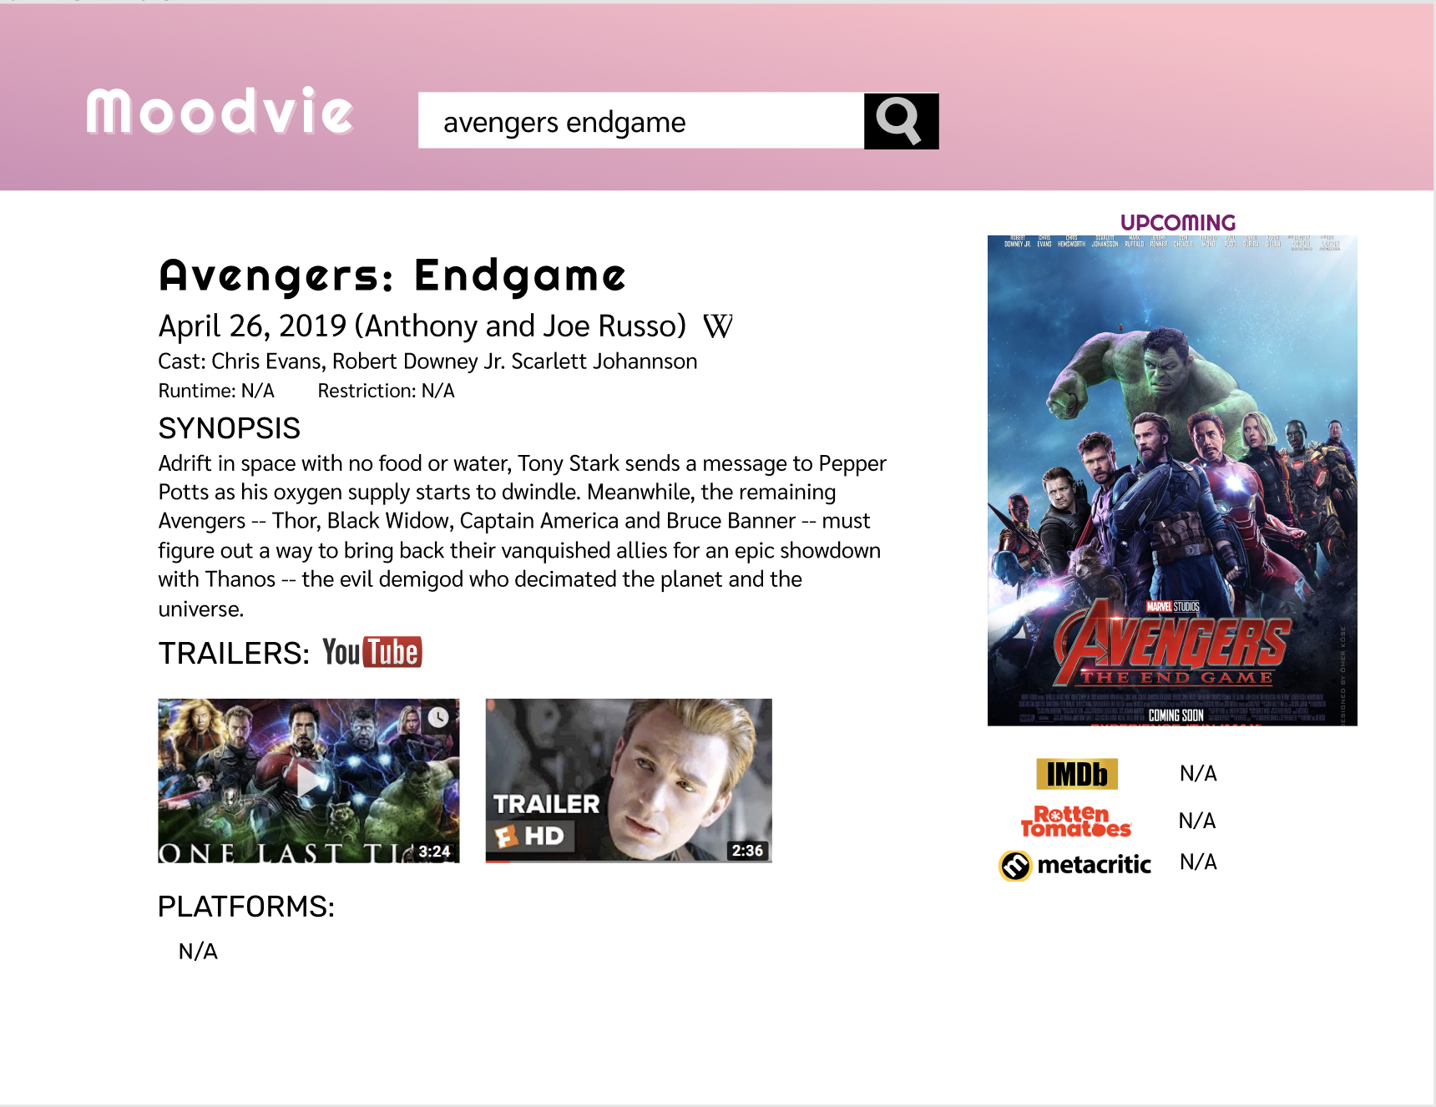

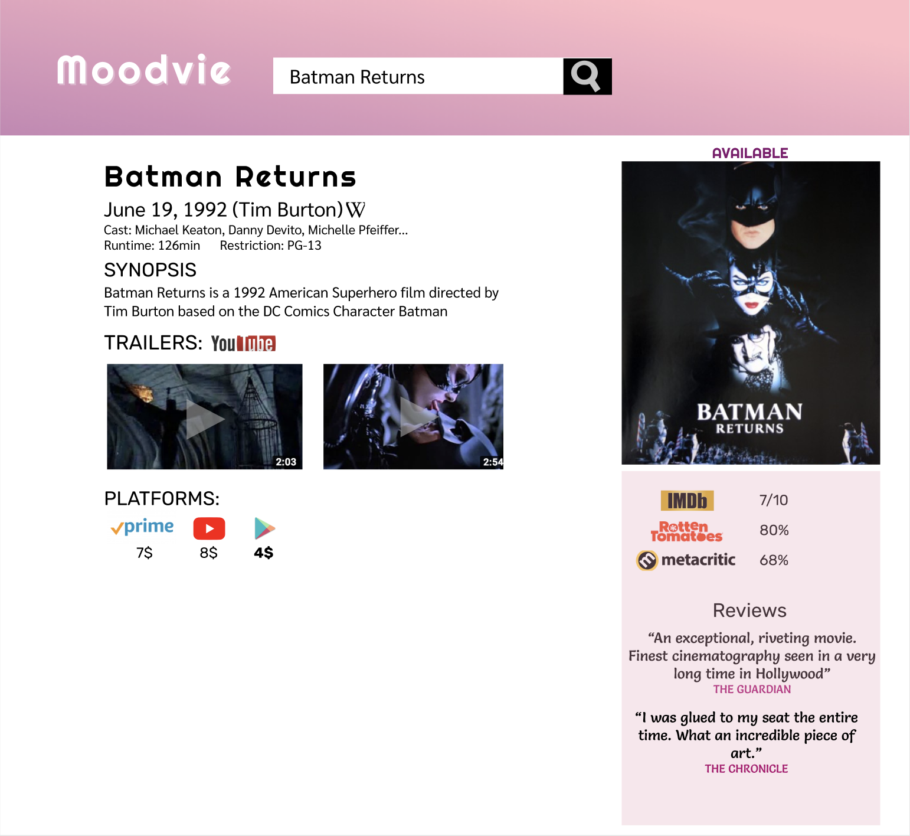

Fig 5. Displays the page for an existing movie that was searched for by the user and the associated information from APIs.